PROJECT PROPOSAL

Development of Common Data Environment (CDE) Platform

with Integrated CMS

Prepared for:

DOXON IT Solutions

Prepared by:

Razi Muhiyadheen & Team

Date:

30/03/2026

Project Proposal

1. Introduction
This proposal outlines the design, development, implementation, and support of a Common Data Environment (CDE) integrated with a Correspondence Management System (CMS) in alignment with the Business Requirements Document (BRD) provided.
The proposed solution will provide a centralized digital platform for managing project documents, correspondence, approvals, workflows, and inspection processes across the design, construction, and handover phases of a project.
The system will follow the ISO-aligned CDE information state model, enabling controlled document lifecycle management across:
- Work in Progress (WIP)
- Shared
- Published
- Archived
The platform will enable collaboration between contractors, consultants, document controllers, project managers, and clients, while ensuring full auditability, structured metadata, and controlled approval workflows.

2. System Architecture
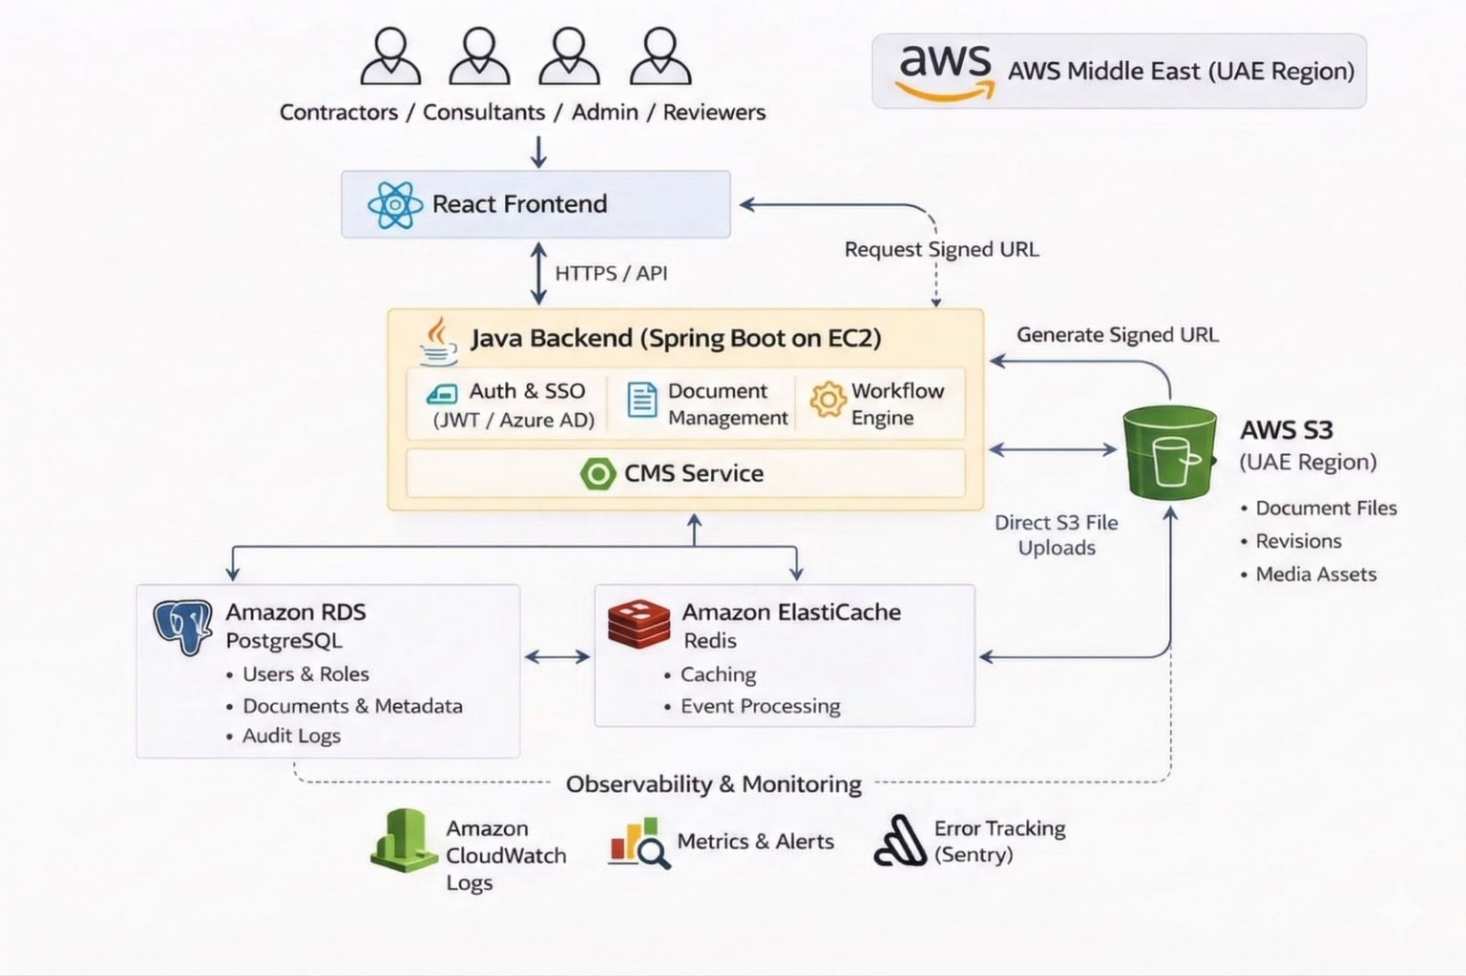
The system architecture will consist of modular components designed for scalability and integration.

Core Modules
- Document Management (CDE Core)
- Workflow Engine
- Correspondence Management System (CMS)
- User & Access Control
- Audit & Reporting
Users will interact with the platform through a web interface, while backend services manage workflows, documents, metadata, and integrations with cloud storage.

3. Technology Stack
The platform can be developed using the following technologies:
Phase 1 – Core Platform
Frontend
- React
- TypeScript
- Tailwind CSS / Material UI
Backend
- Java
- Spring Boot
- REST APIs
Database
- PostgreSQL
Cloud Infrastructure
- AWS EC2 – application servers
- AWS RDS – managed database
- AWS S3 – document storage

Phase 2 – Platform Scaling & Optimization
Additional technologies can be introduced to enhance performance, scalability, and observability.
Caching & Performance
- Redis – caching and event processing
Monitoring & Logging
- CloudWatch – system logs and monitoring
- Sentry – application error tracking

4. Data Flow
Core System Data Flow
Users interact with the platform via the React frontend.
- Frontend communicates with backend APIs through HTTPS.
- Backend services process requests and execute workflow logic.
- Data is stored in PostgreSQL.
- For uploads, the backend generates secure signed URLs.
- Files are uploaded directly to AWS S3.
- Document metadata is stored and linked to the uploaded file.

Document Lifecycle flow
- Create document
- Upload to WIP
- Internal Review
- Submit to Shared
- Consultant Review
Decision:
- Approved → Document Published
- Rejected → Returned with comments → Revision cycle

Workflow & Approval Flow (CDE)
A user (Designer / Contractor) creates or uploads a document.
- The document is stored in the Work in Progress (WIP) state.
- The internal project team performs an internal review.
- The document is submitted to the Shared state for coordination.
- The consultant or reviewer performs review and provides comments.
Decision
- Approved → Document moves to the Published state and becomes available for construction or official use.
- Rejected → Document is returned with comments and moved back to WIP for revision and resubmission.
- After project completion, finalized documents may be moved to the Archived state for record keeping and project handover.
- All workflow transitions and user actions are recorded in the audit log for compliance and traceability.
This workflow ensures that documents follow the ISO-aligned CDE lifecycle:
WIP → Shared → Published → Archived

CMS Content Flow
An authorized user creates a correspondence item such as Letter, RFI, Technical Query, Memo, Site Instruction, or Submittal Transmittal.
- The correspondence is saved as Draft.
- Internal review is performed if approval workflow is configured.
- Once approved, the correspondence is Issued to the intended recipients.
- Recipients acknowledge the correspondence.
- The correspondence remains Open until a response or required action is completed.
- Once the matter is resolved, the correspondence is marked as Closed.
- All communications are recorded in the Correspondence Register and can be linked to related documents, drawings, or RFIs.
Correspondence Types
- Letters
- RFIs
- Submittal transmittals
- Site instructions
- Technical queries
- Memos

Correspondence Lifecycle
- Draft
- Internal Review
- Issued
- Acknowledged
- Open / Responded
- Closed
- Overdue

Features
- Standard templates
- Auto-generated reference numbers
- Document attachments
- Correspondence register
- SLA tracking

Audit & Compliance
The platform will provide full traceability of project data.
Capabilities include:
- Complete document history
- Timestamped user actions
- Immutable audit logs
- Compliance with ISO 19650 document management standards

Integration Flow (API & SSO)
- External systems (ERP, BIM, CRM) interact via REST APIs.
- Authentication can be handled via SSO providers (AWS SSO).
- Data exchange occurs through secure API endpoints.

5. Security Architecture
Security can be implemented across multiple layers:
- Authentication can be handled using JWT-based mechanisms
- Role-based access control can restrict user permissions
- HTTPS encryption can secure all communications
- Secure file access can be enabled via signed URLs
- Audit logs can track user actions such as uploads, approvals, and edits
- Data can be encrypted at rest and in transit

7. Scalability Strategy
The system will be implemented in a phased approach to ensure efficient delivery while supporting future scaling.

Phase 1 – Core Platform
Focus on delivering essential platform functionality with minimal infrastructure.
- Document management foundation
- CMS functionality
- Secure document uploads
- Role-based access control
- Basic workflows
- Core dashboards

Phase 2 – Platform Scaling
Enhancements will include:
- Redis caching for improved performance
- Advanced monitoring and logging
- Infrastructure scaling
- Database optimization
- Enhanced workflows and reporting

8. Monitoring & Logging
Monitoring and logging capabilities will be introduced progressively.

Phase 1 – Basic Monitoring
- Basic infrastructure monitoring
- Server health monitoring
- Database performance monitoring

Phase 2 – Advanced Monitoring
- Centralized logging using CloudWatch
- Application error monitoring using Sentry
- API performance monitoring and alerts

9. Deployment Architecture
The platform can be deployed on cloud infrastructure in the AWS Middle East (UAE) region.

Phase 1 – Initial Deployment
- Frontend hosted on static hosting platform (Vercel or AWS S3)
- Backend running on AWS EC2
- PostgreSQL database using AWS RDS
- Document storage using AWS S3

Phase 2 – Scaled Deployment
- Infrastructure scaling
- Redis caching layer
- Advanced monitoring and observability

10. Backup & Disaster Recovery (Phase 2)
System recovery can be achieved using:
- Automated database backups
- File versioning for recovery
- Cross region replication can be added as a future enhancement
System recovery can be achieved using:
- database backups
- application code repository
- infrastructure configuration
In case of failure:
- New server instance can be created
- Database can be restored from latest backup
- Application can be redeployed
- Files will remain securely available in S3 storage

11. Implementation Plan
The project will be delivered in two phases.

Phase 1 – Core Platform Development
Phase 1 focuses on delivering the platform foundation with CDM and CMS capabilities and minimal UI.
Focus:
- Core CDE functionality
- CMS foundation
- Document uploads and metadata
- Basic workflows
- Initial dashboards
- Role-based access control
Activities include:
- Infrastructure setup
- Backend architecture
- Frontend platform framework
- Document management module
- CMS module
- Basic workflow engine
This phase delivers a working system capable of managing project documents and correspondence.

Phase 2 – Platform Enhancement & Scaling

Enhancements include:
- Document versioning
- Advanced approval workflows
- Reporting dashboards
- Inspection module enhancements
- Integration capabilities
- Performance optimization
- Monitoring and caching

Team Structure

The project can be executed by a focused team of two developers.
Frontend Developer
- Responsible for UI/UX implementation and CMS components
Backend & Infrastructure Developer
- Responsible for APIs, database design, workflows, infrastructure, and deployment

12. Maintenance & Support
Post-deployment support can include:
- System monitoring
- Bug fixes and issue resolution
- Security updates
- Performance optimization
- Feature enhancements

13. Timeline

Phase 1 – Core Platform
- Architecture & Setup – 2 weeks
- Backend Development – 4 to 6 weeks
- Frontend Development – 2 to 3 weeks
- Integration & Testing – 1 week
Estimated Duration: 8 to 10 weeks

Phase 2 – Platform Scaling
- Versioning & Workflow Enhancements – 2 weeks
- Feature Enhancements & UI Improvements – 1 to 2 weeks
- Testing & Deployment – 1 week
Estimated Duration: 4 to 6 weeks

14. Cost Estimate
Development Cost

Phase 1 – Core Platform Development (65%)
Phase 1 focuses on building the foundational platform including CMS functionality, document management structure, secure document uploads, and core workflows.
Estimated development cost:
₹4,36,800 – ₹5,82,400
This includes:
- architecture design
- backend development
- frontend application development
- document upload implementation
- CMS functionality
- basic workflows
- authentication and role management
- initial deployment

Phase 2 – Complete Platform Development (35%)
Phase 2 focuses on completing the platform with advanced features and full workflow capabilities.
Estimated development cost:
₹2,35,200 – ₹3,13,600
This includes:
- document versioning
- complete workflow and approval logic
- UI enhancements and dashboards
- integration capabilities
- performance optimization
- system testing and final deployment

Effort Estimation
Phase 1: 8 to 10 weeks
Phase 2: 4 to 6 weeks
Total Duration: 12 to 16 weeks
Working hours per week: 40 hours
Estimated total effort: 480 to 640 hours (combined team effort)
Effective hourly rate per team: ₹1,400

Total development cost: ₹6,72,000 – ₹8,96,000
Cloud Infrastructure Cost (Monthly)
Estimated monthly cost: ₹5,000 – ₹10,000
- Application server hosting (EC2): approximately ₹2,000 – ₹3,500 per month
- Managed database service (RDS): approximately ₹1,600 – ₹2,500 per month
- Object storage for documents (S3): approximately ₹400 – ₹1,600 per month
- Caching service (Redis): approximately ₹800 – ₹1,600 per month
- Monitoring and logging services: approximately ₹400 – ₹800 per month

These costs may vary depending on:
- number of users
- document storage size
- system usage levels

Maintenance & Support Cost
Estimated annual maintenance: ₹1,20,000 – ₹2,00,000
Includes:
- bug fixes
- monitoring
- updates
- optimizations

Cost Summary
Phase 1 Development: ₹4,36,800 – ₹5,82,400
Phase 2 Development: ₹2,35,200 – ₹3,13,600
Total Development Cost: ₹6,72,000 – ₹8,96,000
Monthly Infrastructure Cost: ₹5,000 – ₹10,000
Annual Maintenance Cost: ₹1,20,000 – ₹2,00,000
These estimates provide a scalable and cost-effective approach for delivering the proposed CDE platform.

Payment Milestones
The project can follow milestone-based payments structured as follows:
- 30% at project initiation
- 40% after phase 1
- 30% after delivery
This structure helps ensure transparency and aligns payments with project progress.

15. Conclusion
The proposed CDE platform will provide a secure, scalable, and ISO-aligned environment for managing project documentation, correspondence, workflows, and inspection processes.
The phased development approach allows rapid deployment of a functional system while supporting future enhancements and scaling.
We look forward to collaborating with DOXON IT Solutions to successfully implement this platform.

